Computer Science
H446 Programming Project
Cyber Maze Quiz

Table of Contents
- Introduction: Planning and Project Selection 4
- Analysis: Proposed Solution: Introduction to my Cyber Maze Game 8
- Analysis: Justification for Programming a Solution 10
- Analysis: Stakeholders 13
- Analysis: Research – Board Games 16
- Analysis: Research – Online Games 18
- Analysis: Research – Cyber Online Games 21
- Analysis: How Research Identifies and Justifies Suitable Approaches 22
- Analysis: Initial Survey of my Sixth Form Stakeholders informed by the research above 23
- Analysis: Initial Engagement with my Computer Teacher Stakeholder 25
- Analysis: Initial Engagement with a contact within NCSC 26
- Analysis: Initial Engagement with my school Network Manager 26
- Analysis: System Requirements and Success Criteria for Proposed Solution with Justification 27
- Analysis: Essential Features of my Proposed Solution 31
- Analysis: Hardware and Software for my Proposed Solution with Justifications 34
- Analysis: Planned Methodology for my project 35
- Analysis: Limitations of my Proposed Methodology and Solution with Justifications 36
- Analysis: Test Plan for Post Development Functionality 37
- Design: Top Level Approach to Development with Justification 43
- Design: Overview of detail within each Iteration with Justification 44
- 1st Iteration: Database Development: Design 46
- 1st Iteration: Creating Relational Database: Development 57
- 1st Iteration: Database Development and Testing: Adding Data 60
- 1st Iteration: Database Development and Testing: Maze and Clues 63
- 1st Iteration: Evaluation of Database Development and Testing So Far 64
- 1st Iteration: Develop and Test: Use Cases for Play and Leaderboard 64
- 1st Iteration: Evaluation of Use Case Learning 67
- 1st Iteration: Continued Development of Leaderboard 68
- 2nd Iteration: Developing Game Play: Decomposition of Functions Layout and Requirements 69
- 2nd Iteration: Developing Game Play: Justification for Functions Approach 74
- 2nd Iteration: Developing Game Play: Prototype Requirements 75
- 2nd Iteration: Developing Game Play: Design 77
- 2nd Iteration: Informal Chat with Sixth Form Stakeholders 84
- 2nd Iteration: Design Survey of Sixth Form Stakeholders 85
- 2nd Iteration: Design Response to Stakeholder Feedback 87
- 2nd Iteration: Game Operation 88
- 3rd Iteration: Graphical Interface Development 174
- Testing to Inform Evaluation 286
- References 312
- Appendix A: Brainstorm for Project Ideas 319
- Appendix B: Stakeholder Research 320
- Appendix C: Source Code 324
- Appendix D: Year 12 Evidence of implementing a flat file log on to a database and the subprograms to manage it. (20 Pages) 389

Introduction: Planning and Project Selection
  - Planning Framework: I plan to use the following planning framework to keep me on track with this Computing NEA project and I will adjust as needed. The aim of this planning framework is to break the project into smaller steps, so that I can keep track of progress towards completing my project.
No | Stage | Activity | Achieved?
1.1 | Planning | Framework, Brainstorm, Project Ideas | 
2.1 | Problem Analysis | Problem Identification
2.2 | Problem Analysis | Stakeholders
2.3 | Problem Analysis | Research of the Problem
2.4 | Problem Analysis | Specification of the Proposed Solution
3.1 | Solution Design | Problem Decomposition
3.2 | Solution Design | Description of the Solution
3.3 | Solution Design | Success Criteria
3.4 | Solution Design | Approach to Testing
4.1 | Solution Development | Iterative Development Process
4.2 | Solution Development | Testing to Inform Development
5.1 | Evaluation | Final Product Description
5.2 | Evaluation | Evidence of Testing
5.3 | Evaluation | Evaluation of Success Criteria
5.4 | Evaluation | Maintenance of Final Product
5.5 | Evaluation | Potential Further Development
6 | References | Completed Reference List

  - Brainstorm: To find a subject for this project, I thought about different things that interest me such as my hobbies which include travel, pets, games and music, my current stage of life such as driving lessons, school and university, as well as my career aspirations in cyber security. A lot of these ideas originated when I chose a topic for my EPQ project the previous year, so these areas gave me a good starting point when I sat in front of a very large blank piece of paper to do the brainstorming. I considered each area in turn and tried to think about ideas that might be suitable for a computing project. I wanted this project to keep me interested for multiple months, so after the initial capture of ideas, I then zoomed in on the things that I would be more interested in pursuing as a project by putting a plus sign next to them on the brainstorm sheet.

  - The diagram below is a word art version of my brainstorm session. I created the word art to make it more legible, but my original paper version can be seen in Appendix A.
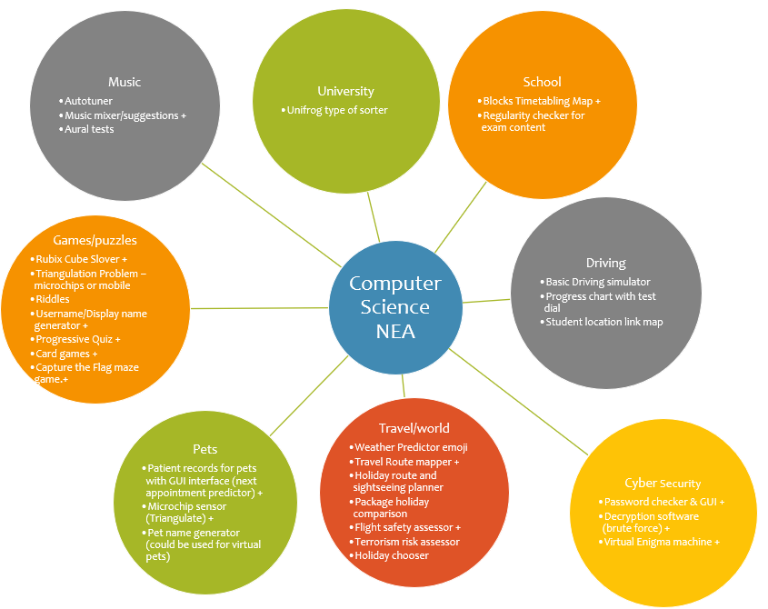

  - Long List to Short List of Project Ideas: I had 14 ideas from my brainstorm that I had previously marked with a plus sign and these formed my long list of ideas for the project. I considered this list against the NEA project criteria¹ and my own personal preference, and I decided to explore a short list of 3 possible projects that would offer enough complexity to fulfil the NEA criteria, whilst also being the projects that I find most interesting. I am interested in cyber security, and I have done a lot of Capture the Flag exercises through Cyber Discovery, Cyber Centurion and CyberFirst, so for me, the Virtual Enigma Machine and the Maze Type Game with cyber security questions were the front runners for my shortlist. The third spot on my short list could have been a number of projects but in the end, it was personal preference that led me to select the Card Game – this was because I had been on an Outward Bound course recently and I really enjoyed playing and learning new card games. I thought all three short listed projects could provide the complexity that I would need to show in this NEA to meet the marking criteria:
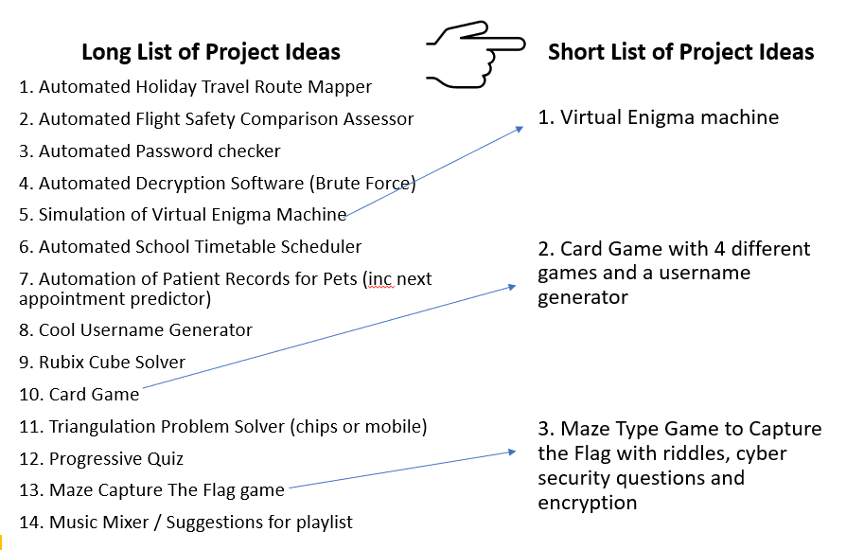
  - Project Proposals: I created project proposals for my three short listed projects to help me decide which one to pursue. These are my three project proposals:
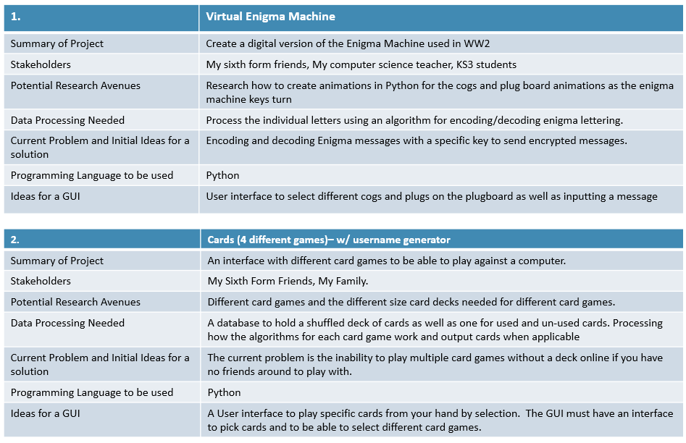

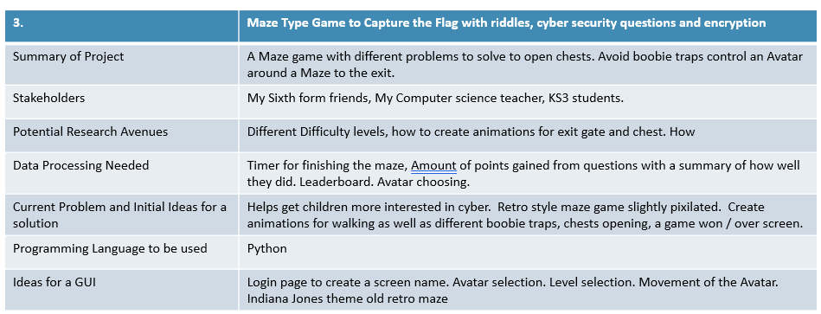

  - Project Selection: I have chosen my third project idea because it is the one which interests me the most and allows for more creativity than the other two project ideas. It also relates to my particular interest in Cyber Security so for me, this was an obvious choice.

Analysis: Proposed Solution: Introduction to my Cyber Maze Game
  - I am aiming to create a fun game that my sixth form friends would want to play that will expand their knowledge of some Cyber Security terms. The game will need to be quick to complete because my friends don’t have that much spare time, it needs to be fun and it will need to offer a bit of competition with leaderboards to compare their progress against each other. My computer teacher may want to use my game with younger students because I know there are not many resources for introducing pupils to cyber security, so my game could be used as a fun introduction to the subject, and it might even persuade more people to look at cyber security as a possible career.

  - My concept for this project is to create a game with five features: a maze, a hero, hazards or a spy to hamper the hero, clues that lead to rewards to help the hero, and an exit gate with a flag to capture. The player will control the hero and will move the hero around the maze. Along the way, the hero will find clues, which will be a cyber or cyber security puzzle to solve or task to complete. Solving the clues will give the hero rewards, which could be coins or energy for the hero or points, which will be displayed. The clues will have different levels of difficulty, and the level of reward will depend on the level of difficulty of the clue, for example Easy (10 points), Medium (20 points) and Hard (30 points). The hero will also experience hazards or spies along the way that will reduce the hero's score or energy level or stash of coins.

  - Features of the game will depend on my research but could include:

- Quiz questions relating to cyber security. These could include decrypting challenges, but the content of the clues will depend on my research and stakeholder feedback. I may choose to include this as a feature of my computational solution to encourage learning about cyber security in order to prompt interest in cyber security challenges like CyberFirst in younger pupils and to expand basic knowledge for sixth formers.
- Rewards could take the form of points or health bars to give the hero energy and greater speed through the maze. I may choose to include this as a feature of my computational solution to encourage repeated use of my game to gain higher scores/rewards and this will further embed the learning about cyber security gained from answering the quiz questions.
- Boobie traps that the hero needs to navigate around to avoid being delayed. I may choose to include this as a feature of my computational solution to add challenge and fun to the game that will increase its popularity within my stakeholders and gain repeated plays.
- Hazards that need to be defended against like incoming arrows or boulders, which could kill off the hero. I may choose to include this as a feature of my computational solution to provide the challenge of losing a life by the hero that should encourage the player to become more skilful to avoid their hero dying.
- An exit gate which reveals a winner's flag when the hero escapes from the maze. I may choose to include this as a feature of my computational solution to provide a sense of completion for the gamer.
- Different characters or colours for the hero so that players can choose what sort of character to be. I may choose to include this as a feature of my computational solution to encourage attachment to the game that comes from the player being able to select their own avatar.
- A timer to show how long the player takes to complete the maze, which could be turned off if the player doesn’t want the stress of being timed. I may choose to include this as a feature of my computational solution to provide a means of creating a leaderboard, which I believe will be wanted by my stakeholders.
- A display that shows the energy level/health/lives remaining of the player which will decrease or increase as the player contacts with boobie traps, hazards and rewards. I may choose to include this as a feature of my computational solution to encourage engagement with the game and sense of accomplishment.
- A leaderboard to rank by the time taken to complete the maze, or how large a score the hero achieved, or how long the hero lived for! I may choose to include this as a feature of my computational solution to provide the competitive element and enable progress tacking of pupils that I believe my stakeholders will want.
- Monitoring to see how players improve or how many clues are solved. I may choose to include this as a feature of my computational solution to enable my teacher stakeholder to monitor progress amongst their pupils in learning about cyber security.
- A “Game Over” screen to finish the experience. I may choose to include this as a feature of my computational solution to offer a sense of completion to stakeholders who are playing the game.

Analysis: Justification for Programming a Solution
  - To justify programming a solution, I have compared different aspects of the game to playing it as a manual board game:

  - Moving the Hero: On a board game it is easy to follow the path and move the hero. With code, the player doesn’t need to wait for their turn, so the game moves faster and allows for immediate reaction to threats and challenges, so it is more engaging, which will please my stakeholders.

  - Moving the Spy: On a board game there would need to be instructions, probably on a card or from the throw of a dice, that decides how the spy will move. This takes time and slows down the game. With code it is possible to program different algorithms so that the movement of the spy is done quickly. This could be done using Dijkstra’s Shortest Path or A* Algorithm. This would make the spy move independently of the hero without waiting a turn or reading a card.

  - Hazards: In a board game hazards in the maze would be fixed to a position on the board or within a deck of hazard cards. With code it is possible to program different algorithms to create the hazards, which speeds the game up and provides the element of surprise.

  - Clues/Challenges to Solve (Easy Medium hard): On a board game there could be different piles of clue cards (easy medium and hard) that the player chooses to select. This could be a free choice or there could be a rule that e.g, makes the player select a medium clue after choosing x number of easy clues. With code the hero could have free choice or algorithmic choice depending on their answer to the previous questions. For example, with programming I could create an algorithm to select a clue immediately based on the number of previous correct answers. This will keep up the speed of the game.

  - Timer: On a board game if I wanted to put a maximum time on solving a clue or completing the maze, I would need to use a stopwatch or an egg timer. With code I could set a timer for solving the clue or completing the maze within the code.

  - Log Results: On a board game producing a leaderboard would need a log to be recorded on a piece of paper about each game, which could include the number of clues solved, the type of clues solved, the total score, the health of hero, the time taken to complete the maze etc. The paper records would be difficult to sort on different data points, and the paper could get lost or damaged. With code a data log could be achieved with a database that could be easily and quickly sorted on different data points, and it would be backed up to keep it safe.

  - Leaderboard: On a board game it would be time consuming to produce a leaderboard because the data log of results for each player would need to be sorted manually in descending order after each game. With code the most recent results could be easily collated and sorted into the list. The Leaderboard could easily be shuffled according to different values such as the score, the time taken, the number of hard clues solved etc. A coded database query could quickly query and sort the database records.

  - Game space: On a board game the board doesn't have much ability to change and so it is well known and could become a bit boring. With code the background graphics for the game could change either randomly, per a set time period or according to the difficulty level selected.

  - Using Abstraction and decomposition with modular sub programs it should be possible to develop a coded game in stages.

- Abstraction. This approach removes irrelevant detail and simplifies the game mechanics to the most basic level. The following drawing shows the abstraction for my game solution:
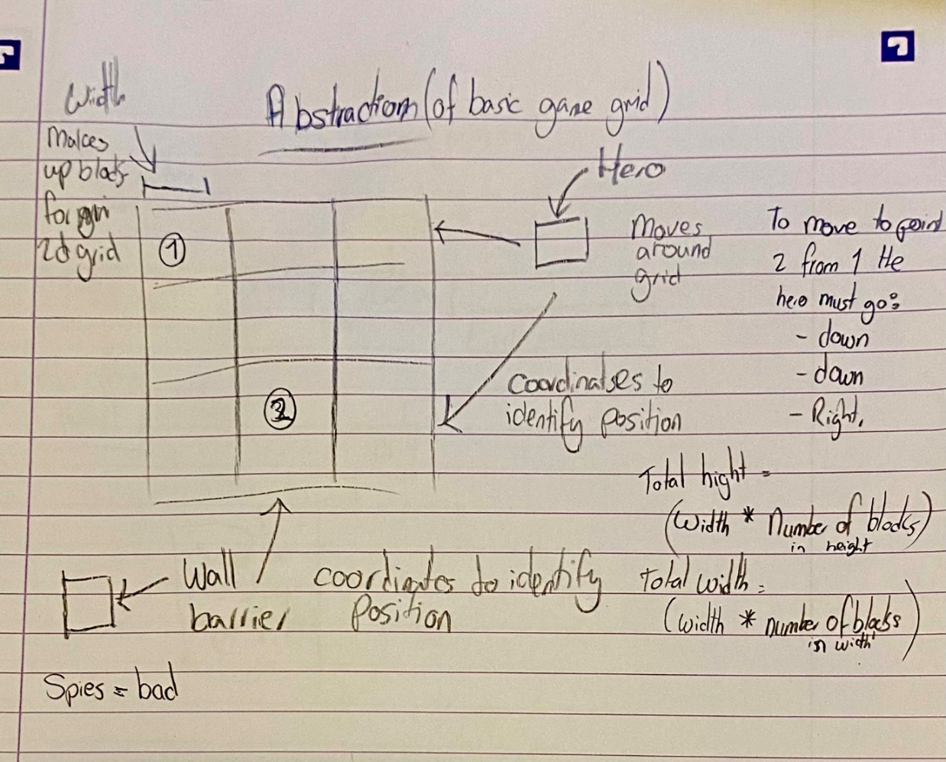

- Decomposition. This process breaks the overall solution into small problems that can be solved one by one and are more manageable for me as the developer. The following hierarchy diagram shows my decomposition of the game.

Analysis: Stakeholders
  - A stakeholder is a person, group or organisation with an interest, or stake, in the decision-making, delivery and activities of a project². The stakeholders for this project are sixth form friends, a computer science teacher, my school IT network manager and a cyber security professional. Any survey results and notes from my initial stakeholder meetings are summarised and analysed below, with original documentation in Appendix B.

  - Sixth Form Friends: this stakeholder group will make use of the proposed solution by playing the game for relaxation during breaks between lessons. It will be appropriate to their needs because it will be a short game (they don’t have much spare time), it will be fun (it needs to engage them), it will appeal to their competitive natures through leaderboards, and it will teach them some things about Cyber Security which may be useful to them as they leave school and start careers. I reached out to my friends in the sixth form with a survey to capture their requirements and I have put this survey after my research in this report because I used the research to inform my survey. They enjoy problem solving games during their down time and they like playing simple games that are easy to learn. They like retro graphics and they use games for entertainment with some challenge and a bit of learning. They compare scores with each other and would like to create an account and make changes such as new name or new PIN. If my game has simple graphics, is fairly quick to do and provides some learning and challenge this group will be happy.

  - Computer Science Teacher: this stakeholder is interested in making use of the proposed solution as a resource that could introduce some cyber security knowledge to pupils in an engaging and interactive way, possibly as a treat at the end of a lesson. It will be appropriate to their needs because it will be a short game (the teacher is looking for a fun filler for a few minutes rather than anything longer), it will be fun (it needs to engage the pupils), and the teacher will be able to track the knowledge learned by the pupils through leaderboards. This stakeholder wants to encourage younger pupils to take an interest in cyber security challenges like the CyberFirst Girls Competition and encourage more to opt for Computer Science at GCSE, so this fun project will offer pupils an example of how studying Computer Science is fun. To monitor progress for this stakeholder, I would need to include a leaderboard for a class or a progress chart for pupils. This stakeholder may want to restrict the challenges according to age and ability. If my game has introductory cyber security challenges and a way to monitor progress, this stakeholder will be happy.

  - School IT Network Manager: The School IT Network Manager is a stakeholder for the proposed solution because if the computer science teacher wants to use it with classes of pupils, then the network manager would need to approve my game for use on the school network and enable it to be accessible for classes to use. I believe the network manager will want to know the size of the database/file, how many players there might be, the different access permissions needed, how new accounts will be created, the requirement for backing it up, the suitability of the content for pupils, and storing pupil information correctly in accordance with GDPR. My proposed solution will be appropriate to the needs of this stakeholder if I keep my game fairly simple, limit it to school users, and control access and data storage. My first prototype which I will develop in this project may not be at a finished development stage where it can be uploaded, and this will be part of my maintenance evaluation for a final prototype.

  - Cyber Professional: A Cyber Professional is a stakeholder for the proposed solution because although they are not the target audience for playing my game, a cyber professional has an interest in resources that encourage young people to believe that cyber security is something interesting that they can do. This stakeholder will be interested in getting the level of difficulty right, so that the game does not put pupils off. The proposed solution will be appropriate to their needs if the game is engaging to students, not too difficult, and encourages some learning about cyber security.

  - General Comment: After thinking about the needs of my stakeholders, I believe that a simple fun retro maze game with different levels of quiz questions and clear access and permission controls, should be appropriate to their needs. My game needs to be simple but engaging and provide some do’able questions that can be timed and result in a leaderboard type of presentation.

  - To keep me focused on stakeholder requirements, I created the following summary of their needs which give key points that can inform my Project Success Criteria. I will conduct research into existing solutions and then survey my stakeholders:

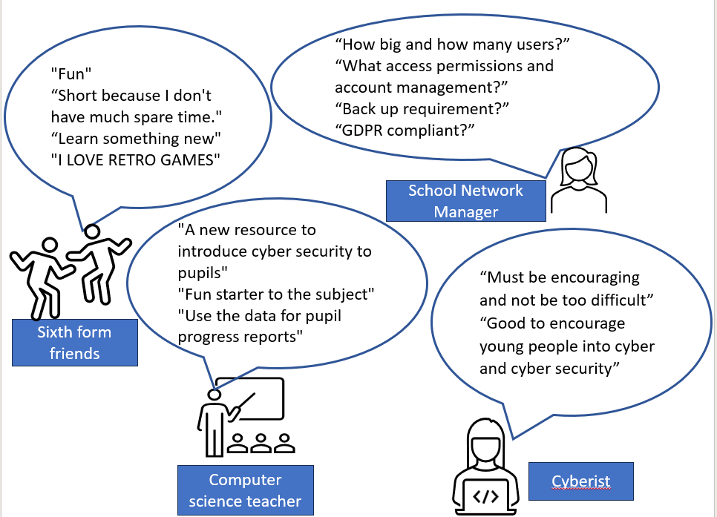
Summary of Stakeholder Needs:

Analysis: Research – Board Games
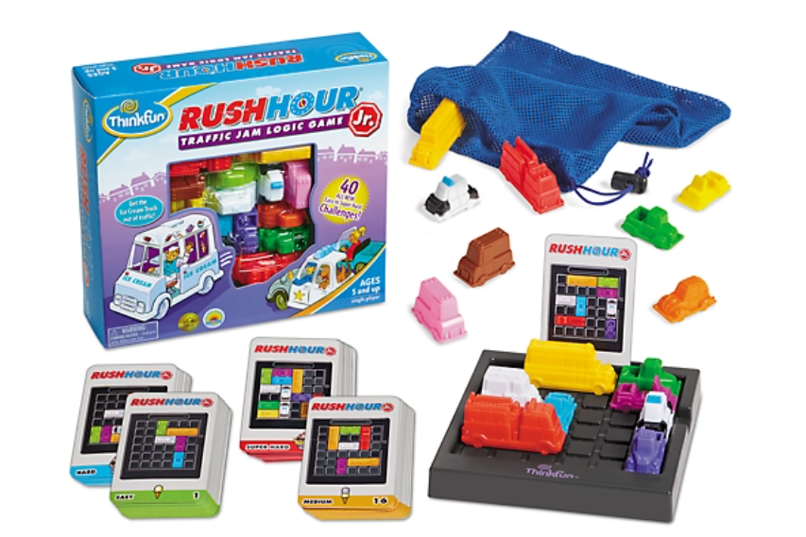
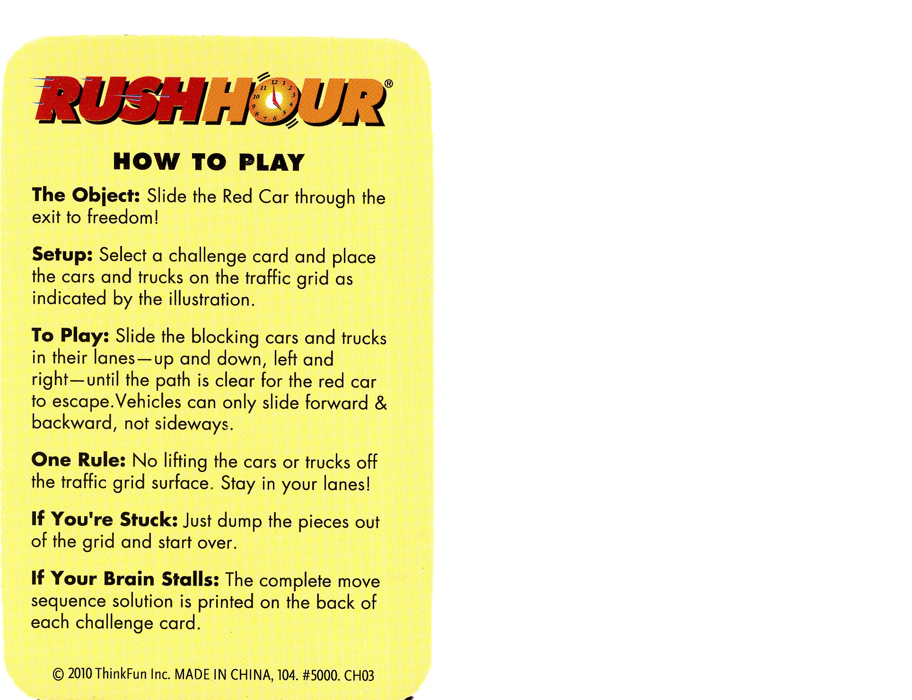
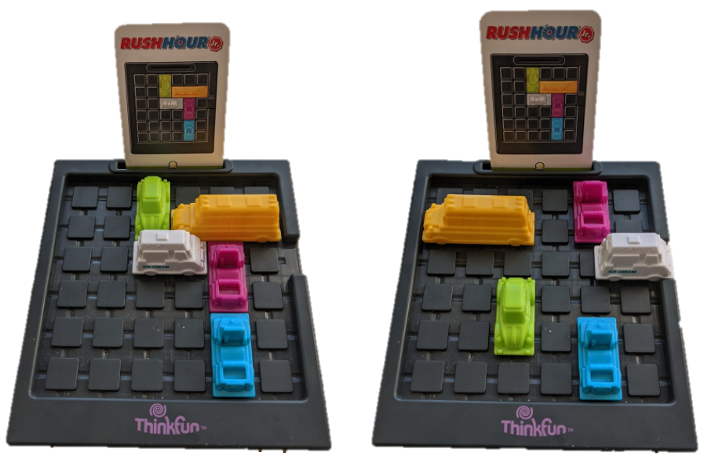
Rush Hour by ThinkFun³.
  - This is a solo game where the player moves plastic vehicles within a 6 x 6 grid to allow ice cream truck to drive away. The vehicles can only move backwards and forwards along their designated tracks and each game starts by replicating the maze set on a puzzle card with up to 15 blocking vehicles and one ice cream truck that is trying to escape. There are 40 puzzle cards that are different levels of difficulty with Beginner, Intermediate, and Expert. The game must be set up before the game can be played and it must be an identical replica of the selected puzzle card. The game can have multiple collaborators trying to solve the problem and the game is over when the ice cream truck escapes from the grid. The solutions are on the back of the cards if you are really stuck! The game is for age 8 plus.

  - What I like about this game: There are different levels of difficulty, and you can self-select whether you are beginner, intermediate or expert. You can easily reset the game if you wish and you can find out the solution by reading the back of the card. There is no time limit, so problem solving is the key focus and the cars are bright, vibrant and easy to see. The instructions are clear and easy to understand, and it is a really simple game idea, which is great for kids.

  - What I don't like about this game: There are a lot of pieces for this game, and it is easy to lose or damage the plastic cars and the cards. It is possible to play on if a card is lost but if a car is lost, the game needs to be thrown away. There are a limited number of cards and once a card has been done and the answer is known, the appeal of the game is lessened.

  - The Features that could be incorporated into my online game: The different levels of difficulty are a good idea to include in my game and so is the idea of making the game easy to restart if a player becomes stuck. I must make my instructions easy to understand and I would like my game to be a simple idea, which is not too complicated.
The Crystal Maze by Rascals Products Ltd⁴
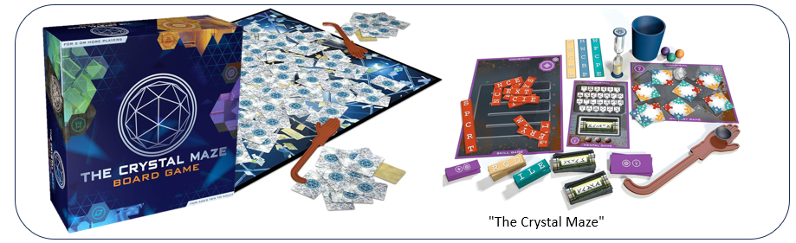
  - This is based on a 1990s TV game show called The Crystal Maze which had a team of 6 contestants doing puzzles against the clock. The contestants attempted a range of challenges and as they completed the challenges, they earned time to use on a final challenge. This is also how the board game works. In the board game, there are 4 themed time zones with a different array of puzzles in them. You are required to work as a team to solve the puzzles. Like the game show, Success is rewarded with precious time crystals and the more crystals you win, the more time you’ll get to spend scrambling for gold tokens in the game’s final challenge. The game contains game boards, puzzle pieces, riddle cards, a huge double-sided board, time crystals and plastic hands. The rules of the game are fairly complicated and the age for the game is 10 plus.

  - What I like about this game: Game cards are reversible, which gives more options for play and the instructions are visual, which I really like. It is a physical game which is appealing, and it needs physical skill because using the long hands to pick up fiddly tokens is difficult. I like the egg timer because it is retro but I really like the App that gives sound effects and a countdown, which makes it a great immersive and interactive experience.

  - What I don't like about this game: It takes a long time to set up (about 30 mins) and it has lots of pieces, which could get lost, as well as a very large rule book to understand. You also need more than one player and it takes a long time to play. This game would not be suitable for my sixth form stakeholders.

  - The Features that could be incorporated into my online game: Including visual instructions could be useful if my game ends up being complicated, and I like the idea of including a soundtrack to make the game more atmospheric and possibly a countdown to build tension might be good to incorporate into my online game.

Analysis: Research – Online Games
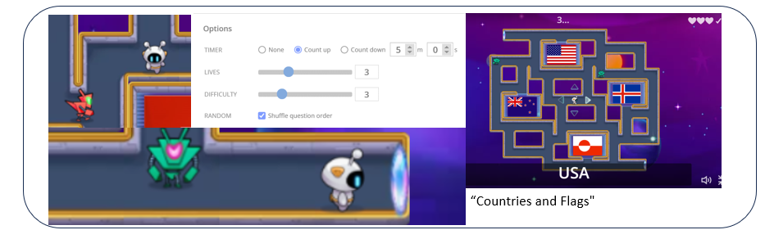
Countries and Flags by bweeks1⁵
  - The player has 3 lives and needs to answer 10 questions on flags of specific countries. The Question appears on the screen with the avatar spawned in the centre and 4 possible maps, before a 3 second countdown in which the enemies are spawned. The avatar and the enemies do not move until the countdown has finished. Then, the Avatar starts moving right and the enemies move around the space randomly. If the Avatar gets within a certain radius of the enemies, the enemies lock onto the Avatar. The Questions are shuffled randomly so they do not get more difficult as the game progresses but the maze does get harder with the arrival of enemies with different detection radii added (they are colour coordinated). At the end of the game, the leaderboard is shown for users who have accounts. Leaderboard scores depend on total time taken to solve the maze. There are also Portals somewhere in the map which can be used to teleport out of a tough spot!

  - What I like about this game: The characters move in a smooth way and the enemies increase in difficulty (speed, algorithm and visibility) with each question answered, so the flow and pace of the game is good and the level of challenge is satisfying. I liked the way the portals work as an escape route and the animation of the enemies changes when they lock onto you, which is visually effective.

  - What I don't like about this game: Some of the answers to the questions don’t seem logical, and although the enemies increase in difficulty, the level of questions remains the same which isn’t very challenging. The timer runs for the entire game time rather than pausing when the question changing animation is happening and the avatar automatically starts moving once the countdown timer ends which is rather annoying if you don’t realise and want to go in the opposite direction

  - The Features that could be incorporated into my online game: I like the way that the answers are hidden around the maze and this could be something to think about in my game and I would like my character to move in a smooth way like in this game, without getting stuck on the corners. I might also take the idea of having different settings that can be changed.
Bird Maze by HappyClicks⁶
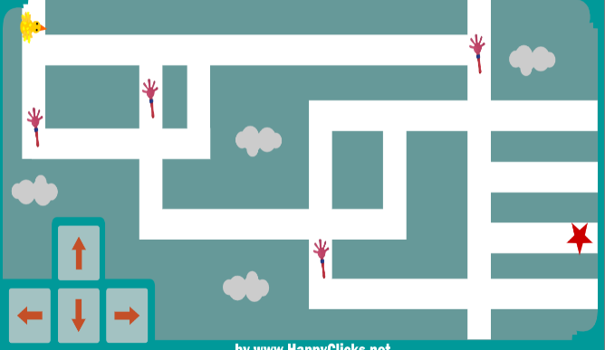
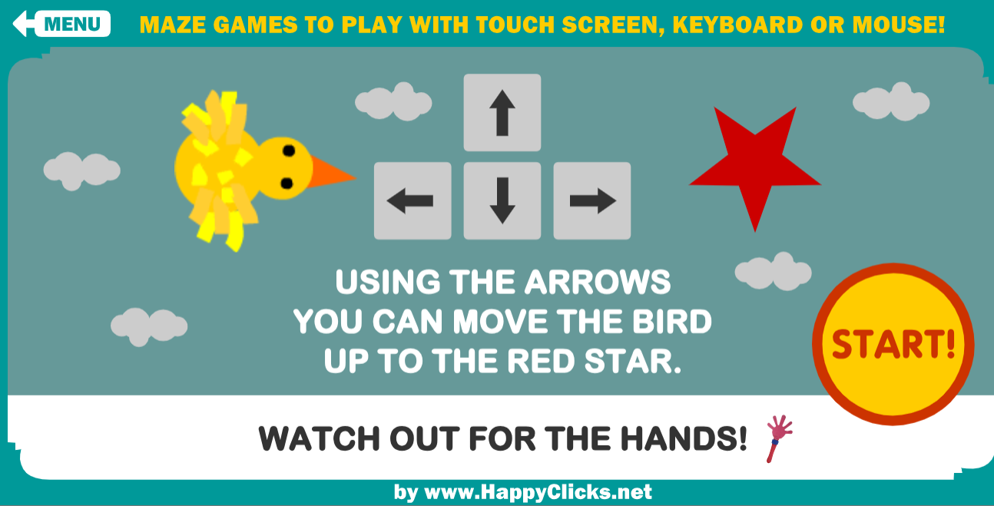
“Bird Maze"
  - The Avatar is a chicken and there are enemies, which are waving hands. The chicken starts at the far left of the maze and the aim is to reach the star at the end without touching any of the hands, because when the Avatar touches the hands, it is sent back to the start of the level. When the Avatar reaches the star, the next level loads, unless all levels have been completed.

  - What I like about this game: I love the retro graphics in this game and I particularly like the simple Avatar. The Avatar moves well and doesn’t get stuck and it is possible to move it with a screen or a keypad, which helps with useability on different devices. I like how the Avatar changes direction when it is moving around the grid. This is a simple game that is really easy to understand, but it is a nice challenge to make sure the Avatar avoids the hands.

  - What I don't like about this game: There are no walls around the maze so falling out of the grid feels like a possibility and there are only 3 levels to the game which are the same every time, so it is fairly limited and repetitive. Also, the enemies can’t move and instead, they just wave, which is kind of cute but pretty limited.

  - The Features that could be incorporated into my online game: The way the avatar changes the direction so that it is always facing the direction in which it is moving is good and I would like to do this through animations. Having dual controls on the screen as well as the keypad also makes the game more useable. I may make these controls invisible, for example, a tilt control or appear on touch command. I might include a setting to return to the start of the game or level.
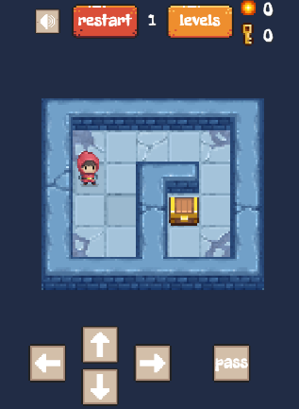
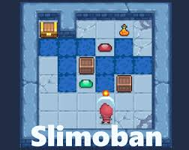
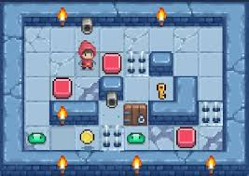
“Slimoban Puzzle Game" by Adgard⁷
“Slimoban"

  - Slimoban is a 30 level puzzle maze game where you need to move boxes whilst you are escaping from monsters or destroying them with a fireball or water. There are three types of monsters in the game: Green ones just standing still, that cannot be destroyed by fire but they can be pushed into water; Blue ones chase the main character and they can be destroyed with a fireball and thrown into the water; Red ones chase you and they can only be pushed in the water. Fireballs can also move boxes, which can also be destroyed if they fall into water. Fireball magic bottles and keys can sink as well.

  - What I like about this game: The Puzzles you can play in the game that have multiple steps and there are 30 levels, which you can solve in slightly different ways so long as you get to the end goal. The style of animation is simplistic and retro, which I really like and the interface is simple to understand. There are also instructions that appear when something new is introduced in harder levels.

  - What I don't like about this game: It is annoying that the character can only move one step at a time and although there is a “pass” button to skip a level, it does not work. There are only enough collectable items to solve the game and not extras so you can choose your path.

  - The Features that could be incorporated into my online game: I would like to incorporate the simple, retro style of game design and graphics. I would also like to include the ability to skip a level as well as including multi step problems. I would also like my maze to have walls.

Analysis: Research – Cyber Online Games
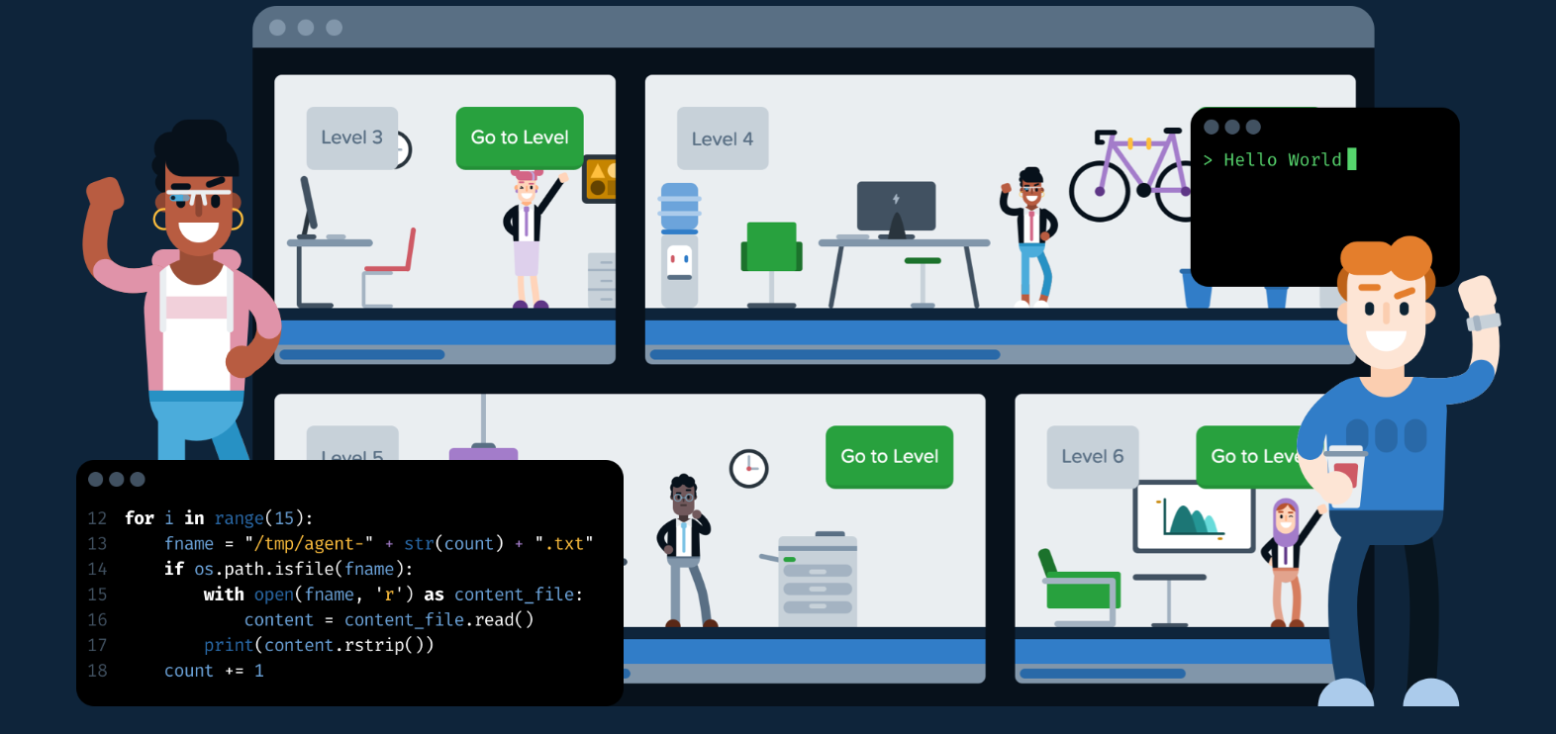
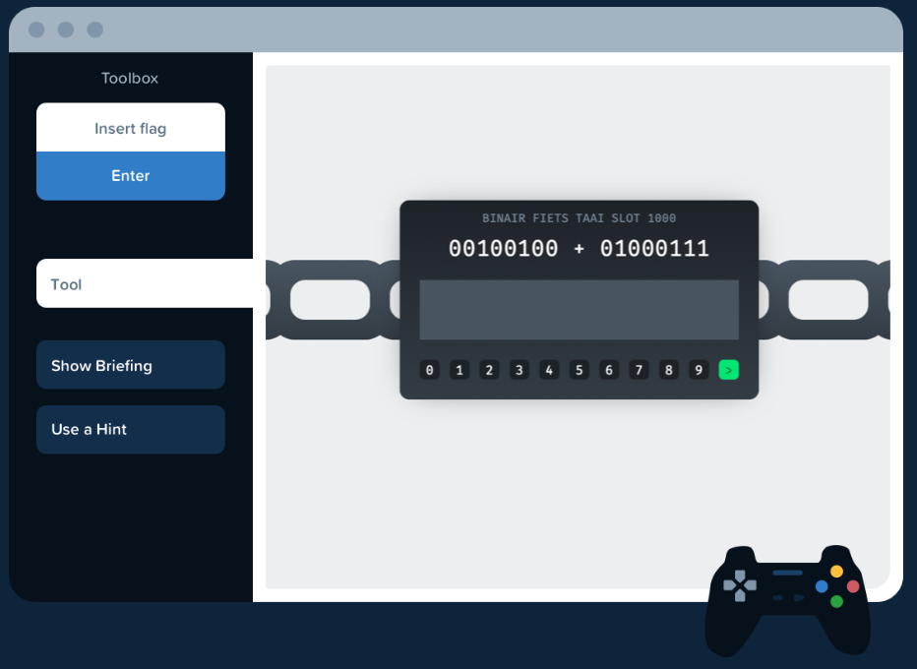
"CyberStart" by Helical Levity Ltd⁸
“CyberStart"

  - CyberStart is the online cyber security game that was created in 2017 for the UK Government’s Cyber Discovery Programme. Cyber Discovery to get 13-18 year olds to try cyber security and it was accessed by over 100,000 students in the UK. CyberStart is still available but is now a commercial paid game. It has 4 stages: 1. Assess: 14 initial challenges to get you into the game. 2. Game: “Capture the Flag” Challenges are grouped into three bases (HQ for general cyber security challenges, Moon Base for Python challenges, and Forensics for specific forensics challenges). Each base has different levels and you unlock the levels as you complete the challenges. There is a Field Manual that gives basic help information. 3. Essentials: This is a set of videos and online labs/quizzes on cyber security knowledge. 4. Elite Camp changed to Final Event (in Covid) for the top 2% of participants.

  - I did the last year of CyberStart when I turned 13 and spent hours on it during Covid. I was really pleased to reach the Final Event in 2021.

  - What I like about this game: it teaches you a huge amount about cyber security, the graphics are a bit retro which I liked and there is a story thread that runs through the challenges for each level. There are lots of prizes in the form of badges to keep you motivated as you unlock the levels and go higher in the game. The field manual was reassuring and offered some basic help. I built a lot of knowledge from this game, learn Python using Moonbase.

  - What I don't like about this game: It was really frustrating because it was so hard but I did it because I was interested. I had to do a lot of research outside of the game to understand how to do the challenges. Some of the challenges were really picky about how an answer was submitted and on Moonbase, it would not accept alternative coding solutions which was frustrating. At times I hated it, but I liked making progress so carried on.

  - The Features that could be incorporated into my online game: I would like to incorporate the retro style of game design and the idea of decrypting messages to find the “Flag”.

Analysis: How Research Identifies and Justifies Suitable Approaches
  - My research involved playing multiple board games and online games repeatedly to understand fully the user experience. The research records above highlight the features that I want to incorporate into my proposed solution, but my learning from the research went much deeper. I gained learning from my research that I am using to identify and justify suitable approaches for my proposed solution.

  - The board games provided a physical experience, and it will be important to replicate that physical experience through allowing the players to choose an avatar. The negatives of the board games were around the number of pieces needed for the game, which might get lost or might need a lot of set up time for the game. This very much justifies my proposed computational solution that will remove the need for multiple pieces and set up time. The long length of time to play the board games was considerable and my sixth form stakeholders are likely to want a quick game, so again, my proposed computational solution will be able to offer an experience that doesn’t take long and can fit into their lives. The board games were also very much limited to the available challenges/questions printed on the cards, which after a while will become known to the user. This justifies my computational solution, which can provide an upload of a new set of quiz questions once the existing questions have become “known”.

  - The online games offered a very different experience for the user from the board games and provided me with a different set of learning. I will need to make sure that my avatars offer a satisfying experience where the user can manipulate them in all directions with ease and can move their player where they wish, rather than being limited by the programme. I will need to make sure that my visuals are fun and the game is logical and easy to understand, with a good colour scheme to reflect the mood of the game that I aim to create. The game that had enemies that couldn’t move was very frustrating and this is a key justification for creating a game that has dynamic enemies which interact with my hero.

Analysis: Initial Survey of my Sixth Form Stakeholders informed by the research above
  - I sent out a survey out to my sixth form friends in order to get their requirements and I decided to use an online survey because I knew that I would get a better response from something quick and online and from either a paper based survey or asking questions in person. I decided on multiple-choice questions to make it easy for them and to direct them into the areas in which I most needed to understand their thoughts.
My Survey Questions | Reason for Including this Question
Do you enjoy problem solving games? | This will tell me if my stakeholders are interested in the type of game that would lend itself to a computational solution.
What sort of problem solving games do you like? | This helps me to understand the type of game mechanics which should appeal to my stakeholders. I am keen to know if they like multi-stage problems or simple question and answer problems.
Do you prefer online games to board games? | This allows me to create the visuals and mechanics of the game that will best suit my stakeholders. Online games and board games have different game mechanics and limitations. By asking this I can change my online game mechanics to suit my stakeholders preferences.
Do you prefer multiplayer or single player games? | This determines if my stakeholders prefer solo learning games or collaborative games. This can help shape my game (e.g. leaderboard competition vs. cooperative mazes).
Duration? | This helps me to understand how long my stakeholders would prefer the game to last. This will influence how many questions, the difficulty of game, the amount of levels (if any).
Do you like retro style graphics for simple games? | This question is to check if my graphic idea will appeal to my Stakeholders.
Do you like games that have a leaderboard? | Leaderboards can add a competitive element. This question allows me to see if my stakeholders would be motivated by ranking systems and if they want to take part.
How do you prefer to log on to a game? | This determines how my stakeholders like to log into a game, and it will guide me on how to authenticate the stakeholders and ensure I can identify users’ progress.
Do you like online games with a countdown / timer feature? | A timer can add urgency and challenge. This question checks whether this feature would be wanted or stressful for my stakeholders.
Would you play an online short problem solving retro maze game? | This is to directly ask my stakeholders whether they are interested in my game idea. Is it a valid idea?

  - This is a screenshot of my online survey:
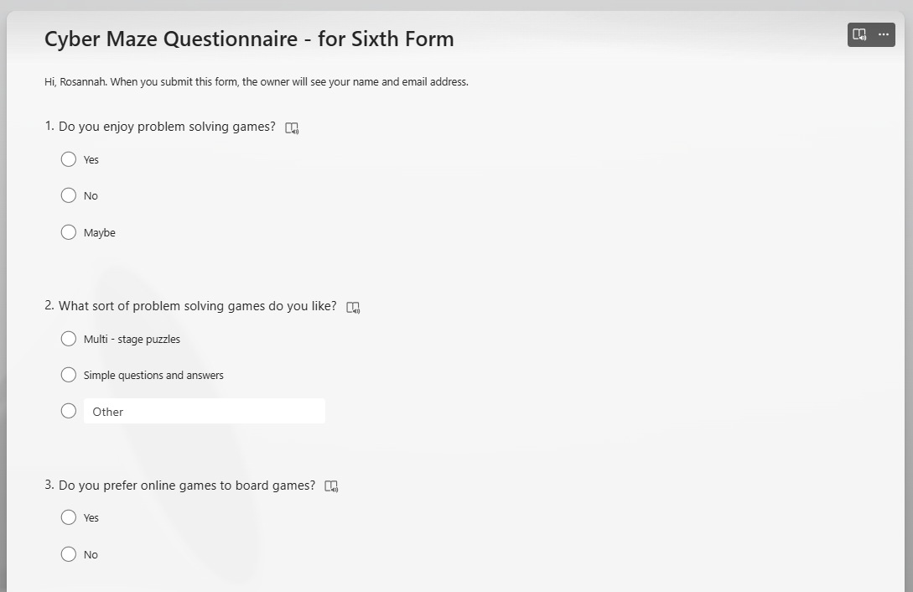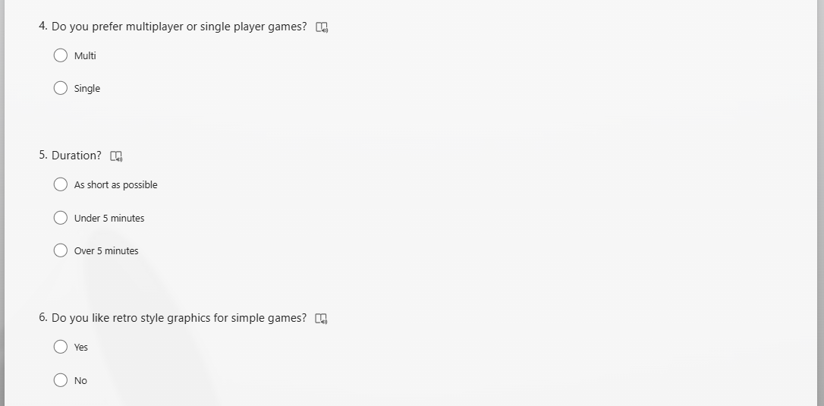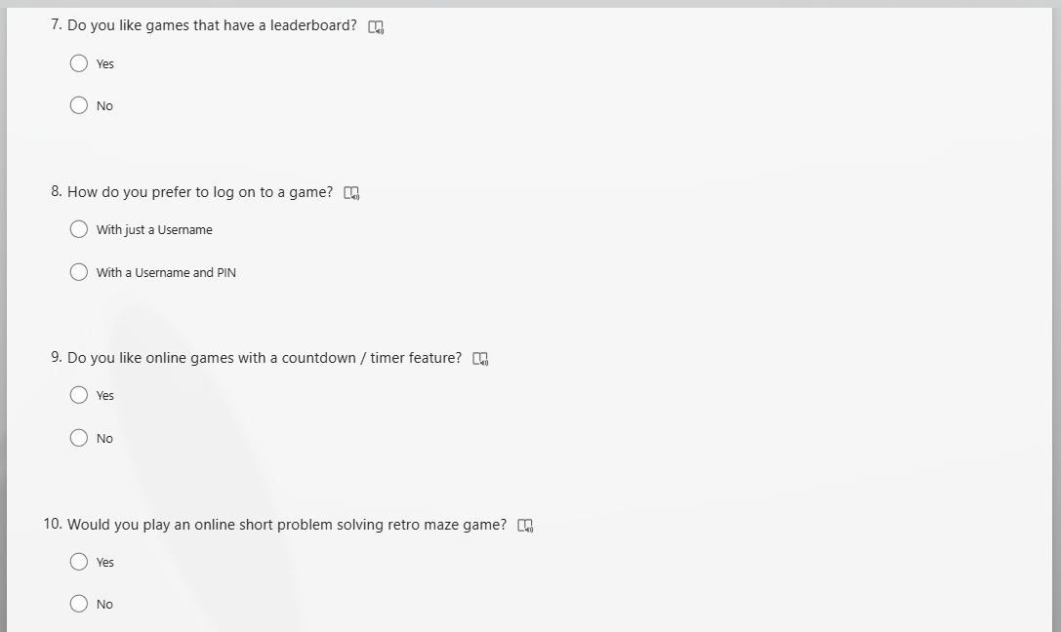
  - This is a screenshot of my analysis of the responses to my online survey.
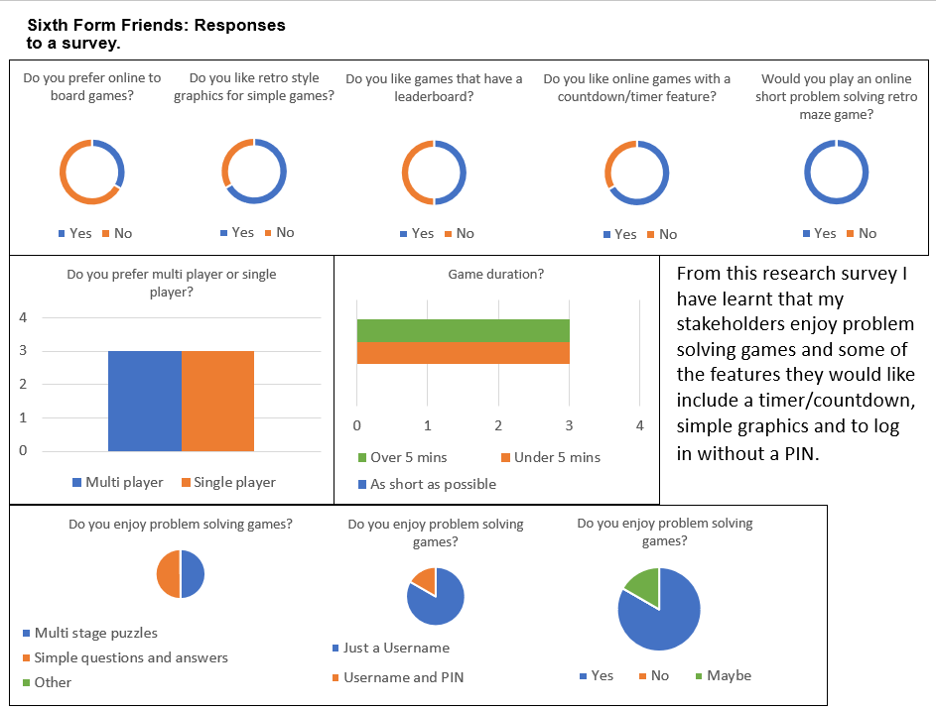
I have decided to combine the options to make there multiple individual questions to finish the game
I have decided to make it a single player game so that I can create a competitive Leaderboard.
I have decided that as they are even, I will not focus on a fixed game duration
I have decided that I would like my game to have a top 5 leaderboard in order for development and competition between players
  - After analysing this data, I decided to take the view of the majority when thinking about the functionality of my game. When I gained a 50-50 response, I decided to go for the solution which I think would work best when considering the other answers, and I have annotated these areas in the analysis above.

Analysis: Initial Engagement with my Computer Teacher Stakeholder
  - I talked to my computer science teacher on 26th June 2024 about my project and this is what he said:
- He would like a resource that introduces pupils to cyber security in a fun way
- He would like something that might encourage people to try for CyberFirst girls
- He would like something that might encourage more pupils to take GCSE computing
- He would like a feature that allows him to check on progress
- He would like a feature like a leaderboard
- His advice was to have different levels of challenge - e.g. easy, medium, hard

Analysis: Initial Engagement with a contact within NCSC
  - I talked to a member of NCSC in August 2024 and these are my notes from that meeting:
I talked to a cyber security professional today from the National Cyber Security Centre. I wasn't allow to record or video our conversation but these are the key things I noted down.
  - NCSC created CyberFirst to encourage school pupils into a cyber security career.
  - CyberFirst is aimed at students from all backgrounds.
  - NCSC created the Year 8 CyberFirst Girls Competition to encourage female talent into cyber security.
  - The aim of CyberFirst is to encourage applications for a CyberFirst bursary.
  - My game proposal could be a good way of encouraging students to think cyber security is fun.
  - My key aim is to make it fun so that people might be open to learning more about cyber security.

Analysis: Initial Engagement with my school Network Manager
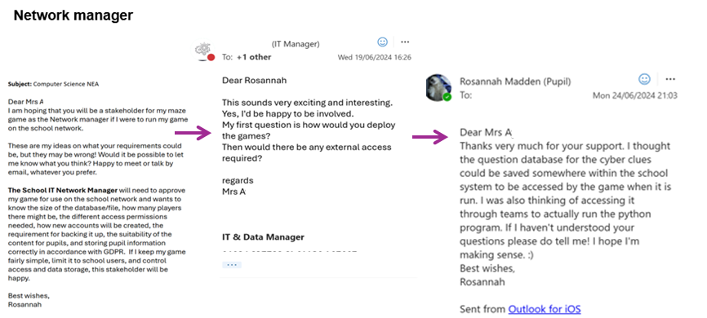
  - I contacted the network manager at school and below is a copy of our initial email exchange. I was slightly unsure at first about Mrs A’s questions, but after talking with her again and catching up in person, I gained a clearer understanding of the sort of things she needed to know if she was going to host my game on the school network. She was supportive of my game idea.

Analysis: System Requirements and Success Criteria for Proposed Solution with Justification
  - Based on my stakeholder feedback, my research into online and board games, and my own ideas, I have identified the following requirements for my project, which form my success criteria for my online maze game. These are grouped into 7 areas: Types of Account; Log On; Home Page Options; Manage Account; Playing the Game; Recorded Statistics; and Leaderboards.

A. TYPES OF ACCOUNT
- There will be two different types of accounts with different privileges:
  - User: This is the Default privilege. A User can have an Avatar for the hero and can only play the game and view leaderboards.
  - Admin: Can View Leaderboards; Can Add/Delete mazes or quiz sets; can view student progress (e.g. accuracy or time taken); can possibly set time allowances; but an Admin cannot play the game unless logged in as a User.
- User will be anyone at school who wishes to play the game.
- Admin will be myself and/or the computer teacher because they will want to set questions and add mazes rather than play the game. They should have the option to add or update quiz sets as part of managing their accounts.
- Why? I am choosing to have two types of account as outlined above because it will fulfil the needs of my stakeholders and enable me to manage the admin for the game effectively. The sixth form stakeholders just want to play the game, but the computer teacher stakeholder wants to upload new quiz sets and content. The network manager wants to ensure that the data is held securely, and so separating admin and user accounts will ensure compliance.

B. LOG ON
- A new player must be able to create an account and choose a username that passes the validation requirements for a unique username in the database. I would like users to create their own account without the need for me to pre add it to the database.
- A new player must be able to select an Avatar (a small graphic image) to represent themselves as the hero and it must be possible to change the Avatar.
- A player must log on using a Unique Username rather than a PIN. This requirement comes directly from my peer survey.
- For validation purposes, the username must be between 1 and 12 characters long and must not contain white space. injection attack which uses ‘(‘ and ‘;’.
- The username entered must match an existing username in the database so that it can be authenticated.
- A new player must be able to create a Username. It must be a mix of upper case and lower case and digit characters, and it can have ‘-’ or ‘_’ as special characters to protect against SQL.
- A maximum of 3 log on attempts will be allowed to prevent brute force attacks that would eventually find an authentic username.
- The ability to manage their accounts must be available to players who are logged in, so that they can change their username (limited to once a week because all records will need to be updated) or delete their account and all associated records.
- A Login Record could have the fields: UserID, Username, Avatar, Permissions (where Permission is ‘user’ or ‘admin’). I may want to add Admin Users myself.
- Why? The essential features listed above provide a good user experience with sixth form stakeholders who want to play the game and create an account, chose an avatar and log in without the help of an administrator. But the features listed above also provide security to protect the accounts of users with suitable authentication and safeguards to protect privacy.

C. HOME PAGE OPTIONS
When a user has been authenticated, they will be presented with the following options and only one option can be selected in order to transition effectively to the next level.
- Play a Game (User Only)
- Manage Account
- View Leaderboards (Admin Only)
- Quit the program or Sign Out
- Add a Quiz or Maze (Admin only)
- Why? A clear set of options will be important for the user to feel comfortable in navigating the programme effectively. This set of home page options covers the main actions that either the User or the Admin will want to achieve.

D. MANAGE ACCOUNT
- The “Manage Account” menu for users will include the following options to modify an existing account:
  - Change Username (with same validations as creating a username)
  - Change Avatar
  - Delete the Account
- The “Manage Account” option for Admins will include the following options to modify an existing account:
  - Set or Adjust Quiz sets
  - Set or Adjust Mazes
  - Set or Adjust timers
  - Modify leaderboard settings
- Why? These are the main activities that the User and Admin will want to undertake either to play the game or administer it and they fulfil the stakeholder requirements established in my research above.

E. PLAYING THE GAME
- Only Users can play the game, and they should have the option to:
- Select a difficulty Level (Easy, Medium, Hard)
- Choose the clue set
- Choose whether to have a timer shown
- Choose whether to be added to a Leaderboard
- The game should be played with the chosen Avatar for the hero.
- Why? This fulfils the stakeholder requirements to have options for difficulty level of quiz questions and other optionality around showing the timer and being on the leaderboard.

F. RECORDED STATISTICS
- Points scored should be recorded.
- Time Taken should be recorded.
- Accuracy Level should be recorded (this is the number of correct clues per difficulty level).
- Number of questions answered correctly should be recorded (slower players may have a higher accuracy level).
- Why? Recording the points scored fulfils the stakeholder requirement for a leaderboard to see top scorers and the other items listed fulfil the requirements of the computer teacher stakeholder in assessing progress.

G. LEADERBOARDS
The Admin should be able to specify the Usernames to be included in the leaderboard and have the ability to hide specific users (e.g. test user account created by the admins). The admins should be able to view the results for a single maze by:
- Score
- Time Taken
The User should be able to view the Leaderboards set by:
- The Difficulty Level
- The Score
- The Time Taken
- Why? Having a leaderboard fulfils a stakeholder requirement to track progress and it will build engagement with the game. The first prototype may not offer all of these options, but the final prototype should cover them all.

Analysis: Essential Features of my Proposed Solution
  - Considering the overall requirements and success criteria, I have created the following structure diagram to decompose the problem:
Cyber Maze Quiz Game
Set Up Database
Log In
Option
Manage Account
Play Game
View Leaderboard
Add Quiz
Add Maze
Add Clue set
Sign Out

  - I can represent the interaction of the various GUIs I need to create for my Cyber Maze game using a state transition diagram (STD).
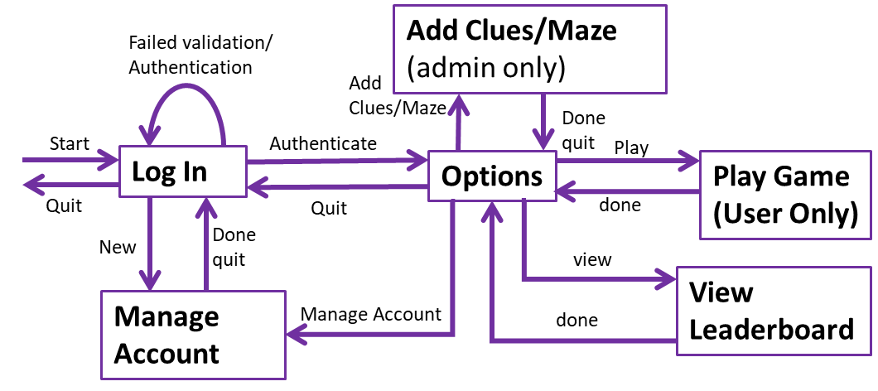

  - The interaction between the distinct modules allows each module to be implemented as its own GUI. There may be ‘sub’ GUIs for any of these.

Name | Description
Log In | - Launches when the program is first run.  - Enables a User to enter their unique username to log in and indicate if they are a User or Admin.  - Enables a new User to create an account  - An authenticated User is then passed to the Options  - Quitting closes the program
Options | - Displays what the user can do next: (configured to the permissions of the person logged in)  - Play a game (User Only)  - View a leaderboard  - Manage account  - Add Clues (admin only)  - Add Maze (admin only)  - Quit and return to log in in case they want to log in again.

Name | Description
Manage Account | - Add a new user – want a unique username to validate and add to the database  - Change Username  - Delete account (with cascade delete)
Play Game | - Select a game to play  - Play it  - Metrics recorded (score, accuracy, time taken)
View Leaderboard | - Select what metric to use  - Select how many e.g. Top 3 or Top 10  - See a table of matching record data
Add Clues/Maze | - Clues:  - Name a clue set  - Add to the list of available clue set  - Maze:  - Name a Maze  - Add to the list of available mazes  - Assign a clue set to a maze (Clue sets must be added first)  (Note: it may be possible to upload a text file to the system and add its file name to the database)

Analysis: Hardware and Software for my Proposed Solution with Justifications
  - After doing my research, I found the retro games with lower resolution graphics really appealing and I would like to create a similar look with my game. This will prioritise processing over graphics, and it will also allow the game to run on a standard desktop/laptop that is running an ordinary operating system such as Windows 10 or MacOS as the computers that my sixth form stakeholders use are low budget machines without high end graphics cards. If I were to develop a 3D game with large graphical demands, the laptops that my stakeholders use would not have enough RAM for the game to function effectively. Post development I understand that the players data will need to be securely stored and so I expect to need a Networked Database server.

  - A Standard Keyboard and Mouse (or trackpad) should be used for text entry and option selection and moving the hero in the game. This is because it will be compatible with the laptops available to my sixth form stakeholder user group and most other users of the game. This initial prototype will not be designed to be compatible with mobile phones because that could lead to formatting issues and require a different type of user interface for playing the game due to the lack of keyboard. Due to time constraints on this project, this will be too much to add in to the first prototype that I will create in this project, however it could be done in a subsequent prototype. I am prioritising laptop compatibility over mobile phone compatibility because my stakeholder group will be playing this game in downtime between lessons, and they will have laptops available to them in school rather than mobile phones.

  - I will use a Python IDE to develop this system because I am most comfortable programming in Python and although I have used other languages, I am not as competent in them. I will also be able to use the built-in libraries as necessary (tkinter⁹ for GUIs, sqlite3¹⁰ for Databases and pygame¹¹ for The Maze) which will make development of my game more efficient.

  - I will use python IDLE v3.8 because it has no AI feature which aligns with the OCR requirement.

Analysis: Planned Methodology for my project
  - Having learned about different development methodologies during my A level course, I thought it would be useful to use a methodology when completing my project. When I create my game, I considered using the Spiral Methodology but discounted it because I do not want my project to be risk driven, which is a key feature of the spiral approach. I would prefer to work in iterations and for this reason am choosing to follow the Agile methodology, which uses sprints with bitesize goals for the development of the project. The Agile approach also has the positives of prioritising stakeholder feedback and being highly adaptable. I hope that I can manage my project effectively using this methodology.

  - From my overall requirements, the analysis above suggests that I can develop the overall solution as a series of priority prototypes. I will need to have or develop:
- A Log On. And if I have time, I can extend to:
  - Add Mechanisms to create and edit accounts
  - Add Admin Features to Add Mazes/Clue sets
- A Relational Database – This will centralise data in reference to Users, Mazes, Clue Sets. (I can manually add data to support development and test).
- A Maze mechanism with an Avatar for the Hero, Spies and Clues. And if I have time, I can extend to:
  - Being able to select a maze by difficulty.
- Save Game stats (according to Username)
- View Leaderboard by score (Users Only, for now for my Sixth form stake holders). And if I have time, I can extend to sort by:
  - The Difficulty Level
  - The Time Taken.
- An Admin Leaderboard view by selecting an individual user (to show it works). And if I have time, I can extend as follows:
  - The Admin should be able to specify the Usernames to be included in the leaderboard
  - have the ability to hide specific users (e.g. test user account created by the admins).
  - to view the results for a single maze by:
    - core
    - Time Taken

Analysis: Limitations of my Proposed Methodology and Solution with Justifications

  - The limitations of my proposed agile methodology might be the risk of over extending my project due to the flexibility of the Agile model, which might delay completion. I will need to keep focussing on my planning framework for this project to avoid this issue and keep the project moving forwards.

  - The limitations of my solution that I can identify at this point are:

- Time constraints – I may not be able to develop the aspects of the project identified above due to lack of time. This is justified because I have to balance my time between this project and competing demands from other A level coursework requirements and I will deliver the maximum possible.
- Skill limitations – As an A level student, I am not expert in using Python and whilst I am keen to learn and develop my skills as part of this project, I realise that there will be some things that I will be unable to do. This is justified because I am starting at a relatively low level of skill and although I am expecting this project to increase my skill, I will have limited time for extensive learning but will learn as much as possible.
- Code Inefficiency – due to my lack of expertise, my coding may be less efficient and is likely to have more bugs than a fully tested and prototyped commercial provider. This is justified because I am starting at a relatively low level of skill level but will learn as much as possible.
- Scale Issues – My solution may have to be adapted or scaled back to overcome any issues that I encounter during development. My plans for unlocking challenges may not be possible to realise during this iteration, so I am fully expecting to scale back to a quiz type solution.
- Laptop Only solution – I appreciate that my game would be more popular if it could be played on mobile phones but for the first prototype, I will focus on the game development for a laptop, which I know will be welcomed by my stakeholder group. This is justified because moving beyond a laptop solution will not be possible in the time available for this project.
- Server Availability – I have talked to my network manager at school and she is one of my stakeholders because I would like to have this loaded onto the school server but I appreciate that with the time available and lack of certified development and testing, my first prototype is unlikely to be available to the school population and will need further prototyping beyond this project. This is justified as a first prototype and I would expect future prototypes to overcome this limitation.

Analysis: Test Plan for Post Development Functionality
  - Based on my overall requirements and proposed limitations, the test plan for post development functionality and robustness is as follows:
If I Start with a clean database, I may have to pre-add mazes and clue sets and Admin accounts
No. | Success Criteria | Description | Input data | Expected outcome
B1 | - A new player must be able to create an account and choose a username that passes the validation requirements for a unique username in the database. I would like users to create their own account without the need for me to pre add it to the database.  - A new player must be able to select an Avatar (a small graphic image) to represent themselves as the hero and it must be possible to change the Avatar.  - A new player must be able to create a Username. It must be a mix of upper case and lower case and digit characters, and it can have ‘-’ or ‘_’ as special characters | Select New User from Log On GUI. |  | Welcome Test7
B1 |  | Create new account | Username = ‘Test7’ | Ok(Selected by User)
B1 |  | Select any Avatar | Avatar = 4
B1 |  | Create Account
B1 |  | Create account with invalid username  (length, type) check | Username = ‘Hello&’  (illegal char &) | Error Invalid Username
B1 |  | Create new account with existing username  authentication check | Username = ‘Test7’  Avatar = 1 | Error Invalid Username
B1 |  | Return to Log On

B2 | - A player must log on using a Unique Username rather than a PIN. This requirement comes directly from my peer survey.  - For validation purposes, the username must be between 1 and 12 characters long and must not contain white space. injection attack which uses ‘(‘ and ‘;’.  - The username entered must match an existing username in the database so that it can be authenticated.  - in order to protect against SQL.  - A maximum of 5 log on attempts will be allowed to prevent brute force attacks that would eventually find an authentic username. | Validation testing  After creating 3 accounts with 3 different avatars:  - ‘a’,3  - ‘Test7’,4  - ‘123456890ab’,2
B2 |  | Log On with 0 character.  (invalid test) | Username = Null char | Error message  (invalid username)
B2 |  | Log On with 13 characters  (invalid test) | Username = ‘1234567890abc’ | Error message  (invalid username)
B2 |  | Authentication Test  Log On with valid username not in database | Username = “Hi” | Error message  (invalid username)  Error Message 3 Failed Log On attempts. Program quits
B2 |  | Log On with 1 character  (lower bound test) | Username = ‘a’ | Welcome ‘a’  Transition to option GUI
B2 |  | Return to Log On GUI
B2 |  | Log On with invalid characters  (Username with invalid chars) | Username = ‘Hello&’  (illegal char &) | Error message  (invalid username)
B2 |  | Log On with 12 characters  (upper bound test) | Username = ‘1234567890ab’ | Welcome ‘1234567890ab’  Transition to option GUI
B2 |  | Return to Log On GUI
B2 |  | Log On with 6 characters  (normal test) | Username = ‘Test7’ | Welcome ‘Test7’  Transition to option GUI
B2 |  | Return To Log On GUI | Select QUIT | Program closes

C | When a user has been authenticated, they will be presented with the following options and only one option can be selected in order to transition effectively to the next level.  - Play a Game (User Only)  - Manage Account  - View Leaderboards (Admin Only)  - Quit the program or Sign Out  - Add a Quiz or Maze (Admin Teacher only) | Once Correctly Logged in the Options are presented | Username = ‘Test7’ | Log In is Hidden, Option Menu Displayed
C |  | Options available to User  (Users should be able to view a simplified leaderboard) | Username = ‘Test7’ | Options Available.  Play a Game  Manage Account  View Leaderboards  Return to Log On
C |  | Options Available to Admin Users | Username = ‘A_Admin’  (create account if necessary) | Options Available.  Play a Game  Manage Account  View Leaderboards  Add a Quiz or Maze Return to Log On
E | - Only Users can play the game and they should have the option to:  - Select a difficulty Level (Easy, Medium, Hard)  - Choose the clue set  - Choose whether to have a timer shown  - Choose whether to be added to a Leaderboard  - The game should be played with the chosen Avatar for the hero. | From Option Play Game | Transition from options to play game. | Options GUI disappears Play Game GUI Appears
E |  | The User can select a game sorted by difficulty level | Username = ‘Test7’  (Log in again if necessary) | Option to view a specific difficulty of games.
E |  | User Selects Easy

D2 | - The “Manage Account” option for Admins will include the following options to modify an existing account:  - Set or Adjust Quiz sets  - Set or Adjust Mazes  - Set or Adjust timers  - Modify leaderboard settings | In practice this is admin management
D2 |  | Add User (in console)  (I will have to add this user manually so normal users (students) cannot become admins by clicking a button). | Username = A_Test  Type = A
D2 |  | From the Log In GUI Select New User | Transition from Log In to manage account | Log In GUI disappears Manage Account GUI Appears
D2 |  | Input an admin Username to access admin options | Username = A_Test | Admin Options appear
D2 |  | Set Quiz | QuizFilename = Cyber.txt | Popup message  Quiz set correctly added and is a valid file  (check the file is not blank and is a valid file)
D2 |  | Set Maze | MazeFilename = Maze1.txt | Popup message  Maze file correctly added and is a valid file  (check the file is not blank and contains no invalid letters for the maze definition)
D2 |  | Set Timers | Timer = 00:05:00  (5 mins) | Popup message  Maximum time set Users will have ’00:05:00’ to complete this maze
D2 |  | Modify Leaderboard settings | Methods of sorting the Leaderboard?  On/Off? | Popup message  Leaderboard settings have been changed default is no longer set
D2 |  | Editing a game  Edit Quiz | QuizFilename = Cyber1.txt | Popup message  Quiz set correctly added and is a valid file  (check the file is not blank and is a valid file)
D2 |  | Editing a Maze | MazeFilename = Maze2.txt | Popup message  Maze file correctly added and is a valid file  (check the file is not blank and contains no invalid letters for the maze definition)
In practice I developed this part of manage account as a separate GUI for the Admin management to enable admins only to manage the mazes and clue sets. The Manage Account option is the same for both types of user and is limited only edit the Avatar.
D1 | - The “Manage Account” menu for users will include the following options to modify an existing account:  - Change Username (with same validations as creating a username)  - Change Avatar;  - Delete the Account | Adding a Username (testing as seen in B1)
D1 |  | From the Log In GUI Select New User | Transition from Log In to manage account | Log In GUI disappears Manage Account GUI Appears
D1 |  | Input a User to edit/create (can be pre-existing) | Username = Test
D1 |  | Avatar selection option. Different Avatar options to select. | Avatar = 2
D1 |  | Save user details | (click on a button of some sort) | Popup message  User saved successfully.
F | - Points scored should be recorded.  - Time Taken should be recorded.  - Accuracy Level should be recorded (this is the number of correct clues per difficulty level).  - Number of questions answered correctly should be recorded (slower players may have a higher accuracy level). | I have shown Stats are returned and included in each User_Maze Record. So to view the Stats use the Leaderboard GUI or Console  Since my requirements I have added additional stats – COMP, Number of questions answered split into levels  The Admin view of the leaderboard shows all the stats whilst the user view shows limited stats | Maze = Maze01.txt  Clues = Cyber.txt  Nickname = Cyber_Attack  User = Test1  Score = 23  TimeTaken = ’00:02:03”  NumEasy = “2”  NumMedium = “3”  NumHard = “3”  Accuracy = “64%” | Pop up with all details in Admin Leaderboard.  Shown within User leaderboard with less stats.

G1 | The Admin should be able to specify the Usernames to be included in the leaderboard and have the ability to hide specific users (e.g. test user account created by the admins). The admins should be able to view the results for a single maze by:  - Score  - Time Taken | In Practice the Admin can only select one user at a time within a game selected.  Log in as Admin  Select view Leaderboard  Select Game (Nickname)  View the order of the drop down (Usernames)  Select the User of interest. | Username = A_Test  Nickname = Cyber_Attack  User(for view) = Test1  Test3 | Pop up message containing detailed stats for that user and that game for the last game they played.
G2 | The User should be able to view the Leaderboards set by:  - The Difficulty Level  - The Score  - The Time Taken | **DO THIS TEST BEFORE G1**  Add Game Starts for 5 users.  Needed (UserIDs, MazeID)  Maintenance:  You can only view the leaderboard in descending score order in this iteration so this could be amended in a future version of my prototype. | Maze = Maze01.txt  Clues = Cyber.txt  Nickname = Cyber_Attack  User = Test1  Score = 23,  User = Test2  Score = 34,  User = Test3  Score = 12,  User = Test4  Score = 54,  User = Test5  Score = 45  (Avatar not important)  Future Development Idea: Show avatar in leaderboard | Scores shown in descending order of score.  (Test4, 53)  (Test5, 45)  (Test2, 34)  (Test1, 23)  (Test3, 12)

